The University of Alabama in Huntsville Space Hardware Club

HELEN Post Mission Report

BalloonSat 76 - Tuesday

# 

# Table of Contents

**Table of Contents**2

**1 - Flight**3

1.1 - Flight Summary 3

1.2 - Pre-Flight Conditions 3

1.3 - Flight Crew 3

1.4 - Launch Operations Parameters 3

1.5 - Landing and Recovery Efforts 4

1.6 - Launch, Landing, and Recovery Complications 4

**2 - Radiation Detection Payload Performance**5

2.1 - Environmental Data Analysis 5

2.1.1 - Overview 5

2.1.2 - Details 5

2.2 - Radiation Data Analysis 6

2.2.1 - Overview 6

2.2.2 - Details 6

2.3 - Significant Events 6

2.4 - Anomaly Analysis 6

**3 - Electric Field Meter Flight Performance**6

3.1 - Electric Field Data 6

3.1.1 - Overview 6

3.1.2 - Details 7

3.2 - Significant Events 7

3.3 - Anomaly Analysis 7

**4 - Camera Footage**7

2.1 - Camera Footage Summary 7

2.2 - Significant Events 7

**5 - Conclusion**7

5.1 - Significant Events 7

5.2 - Lessons Learned 7

5.3 - Mission Summary 7

# 

# 1 - Flight

## 1.1 - Flight Summary

BalloonSat <##> was a <test flight / full mission flight / ground test / etc> of <all HELEN payloads / a full balloon train / all Radiation Detection Payloads / etc> performed on <date>. The objective of this mission was to <test / gather scientific measurements / etc> in <environment>. The mission lasted <duration> and recorded <data highlights>. <Describe anomalies / All payloads performed nominally>. Report recovery status.

## 1.2 - Pre-Flight Conditions

<Timeline>

## 1.3 - Flight Crew

**Table 1: Flight crew names and roles**

|  |  |  |  |
| --- | --- | --- | --- |
|  | Red | Green | Blue |
| Flight Lead | <Flight Lead> | | |
| Station Leads | <Red Station Lead> | <Green Station Lead> | <Blue Station Lead> |
| Fill Leads | <Red Fill Lead> | <Green Fill Lead> | <Blue Fill Lead> |
| Line Leads | <Red Line Lead> | <Green Line Lead> | <Blue Line Lead> |
| RDP Operators | <Red RDP Operator> | <Green RDP Operator> | <Blue RDP Operator> |
| EFM Operators | <Red EFM Operator> | <Green EFM Operator> | <Blue EFM Operator> |
| Balloon Wranglers | <Red Balloon Wranglers> | <Green Balloon Wranglers> | <Blue Balloon Wranglers> |

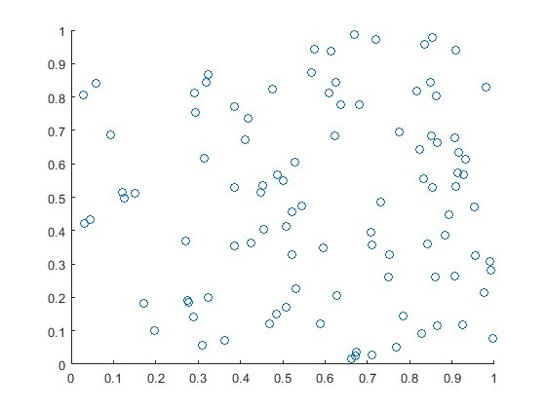

<Team photo if available>

## 1.4 - Launch Operations Parameters

|  |  |  |  |  |
| --- | --- | --- | --- | --- |
|  | Red | Green | Yellow | Blue |
| Launch Locations - Name | <Red Station> | <Green Station> | | <Blue Station> |
| Launch Locations - Coordinates | <Red Lat>, <Red Long> | <Green Lat>,<Green Long> | | <Blue Lat>, <Blue Long> |
| Launch Time | <Red Launch Time> | <Green Launch Time> | <Yellow Launch Time> | <Blue Launch Time> |
| Landing Time | <Red Landing Time> | <Green Landing Time> | <Yellow Landing Time> | <Blue Landing Time> |
| Landing Location - Description | <Red Landing Location> | <Green Landing Location> | <Yellow Landing Location> | <Blue Landing Location> |
| Landing Location - Coordinates | <Red Lat>, <Red Long> | <Green Lat>, <Green Long> | <Yellow Lat>, <Yellow Long> | <Blue Lat>, <Blue Long> |
| Balloon Neck Lift | <Red Lift> | <Green Lift> | <Yellow Lift> | <Blue Lift> |
| Train Weight | <Red Weight> | <Green Weight> | <Yellow Weight> | <Blue Weight> |
| Chute Size | <Red Chute> | <Green Chute> | <Yellow Chute> | <Blue Chute> |
| Balloon | <Red Balloon> | <Green Balloon> | <Yellow Balloon> | <Blue Balloon> |
| Tanks of Helium | <Red Tanks of Helium> | <Green Tanks of Helium> | <Yellow Tanks of Helium> | <Blue Tanks of Helium> |

## 1.5 - Landing and Recovery Efforts

Report landing environment and any recovery efforts made or planned. If no efforts made or planned yet, state that.

## 1.6 - Launch, Landing, and Recovery Complications

Report complications. If none, remove this section.

# 2 - Radiation Detection Payload Performance

## 2.1 - Environmental Data Analysis

### 2.1.1 - Overview

Time Durations

Time on datetime (serial)

Time off datetime (serial)

OPERATION_WINDOWS plot

Maximum altitude

Altitude plot?

GPS_PLOT_COMBINED

Minimum external temperature

Maximum external temperature

External Temperature Plot?

Mean internal temperature

Maximum internal temperature

Internal temp plot

Number of packets actual

Number of packets expected

### 2.1.2 - Details

Time GPS on datetime (serial)

Time GPS off datetime (serial)

Packet number first

Packet number last

Packet number gps on

Packet number gps off

Number of packets gps duration

Number of packets per second

Distance

Acceleration max y

Acceleration max z

Acceleration total plot

Acceleration vertical plot

Acceleration horizontal plot

## 2.2 - Radiation Data Analysis

### 2.2.1 - Overview

Number of suspected TGFs

Time duration FPGA (counter resets)

Counts per second mean 1500

Counts per second max 1500

Spectrum channel b 1500 plot

Counts per second 1500 plot

Deadtime mean percent

### 2.2.2 - Details

Counts total

Counts total 1500

Counts per second mean

Counts per second max

Spectrum Channel A plot

Spectrum Channel B plot

Counts per second plot

## 2.3 - Significant Events

## 2.4 - Anomaly Analysis

# 3 - Electric Field Meter Flight Performance

## 3.1 - Electric Field Data

### 3.1.1 - Overview

### 3.1.2 - Details

## 3.2 - Significant Events

## 3.3 - Anomaly Analysis

## 

# 4 - Camera Footage

## 2.1 - Camera Footage Summary

Duration

Number of detected events

How’d the payload train look?

## 2.2 - Significant Events

List of every lightning detection time & detection value (% screen white or whatever)

# 5 - Conclusion

## 5.1 - Significant Events

## 5.2 - Lessons Learned

## 5.3 - Mission Summary